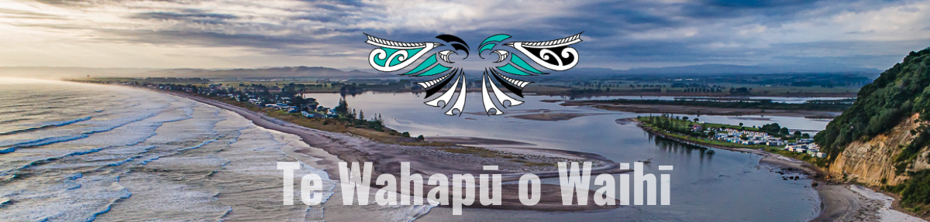
Te Wahapū o Waihī is launching a Waihī Environmental Internship programme: an employment, training and development programme which seeks to upskill rangatahi. This means that we have some incredibly exciting opportunities for our community members.
Internship opportunity
We are on the lookout for ten rangatahi who are keen to embark on a conservation career path. Through our summer internship we aim to help them better understand future employment opportunities, develop skills, achieve certifications, gain confidence, build connections and understand kaitiakitanga (through an iwi lens). The internship will run from mid-December to early-February.
Does the below sound like you (or someone you know):
- aged 16 and over
- committed to pursuing a career in Mahi Taiao – environmental conservation and restoration
- come from at least one of the five iwi that form Te Wahapū
- and either entering years 11 and 12 at high school, or university in 2024 – or recently graduated.
Email us at korero-mai@waihi-estuary.iwi.nz with your contact details if you are interested in applying for an internship position.
Seeking a Kaiwhakahaere/Supervisor
We are also looking for an exceptional individual who can support the development and delivery of our internship programme.
Get in touch if this sounds like you:
- passionate about mentoring and guiding rangatahi
- experience in programme delivery and/or adult education
- a good understanding of ecology and ecosystems.
Knowing how to apply these areas of knowledge into a well-structured learning experience is essential as is connectivity with one or more of the iwi of Te Wahapū. Check out the full job description here.

